**NAME: ___________________________________________________________**

**The Generosity Ladder**

**Equipping Seminar**

**November 17, 2024**

**New Life Community Church - Elgin**

[**www.ChurchLeaderInsights.com**](http://www.ChurchLeaderInsights.com)[**www.newlifeelgin.org**](http://www.newlifeelgin.org) **1**

**The Generosity Ladder**

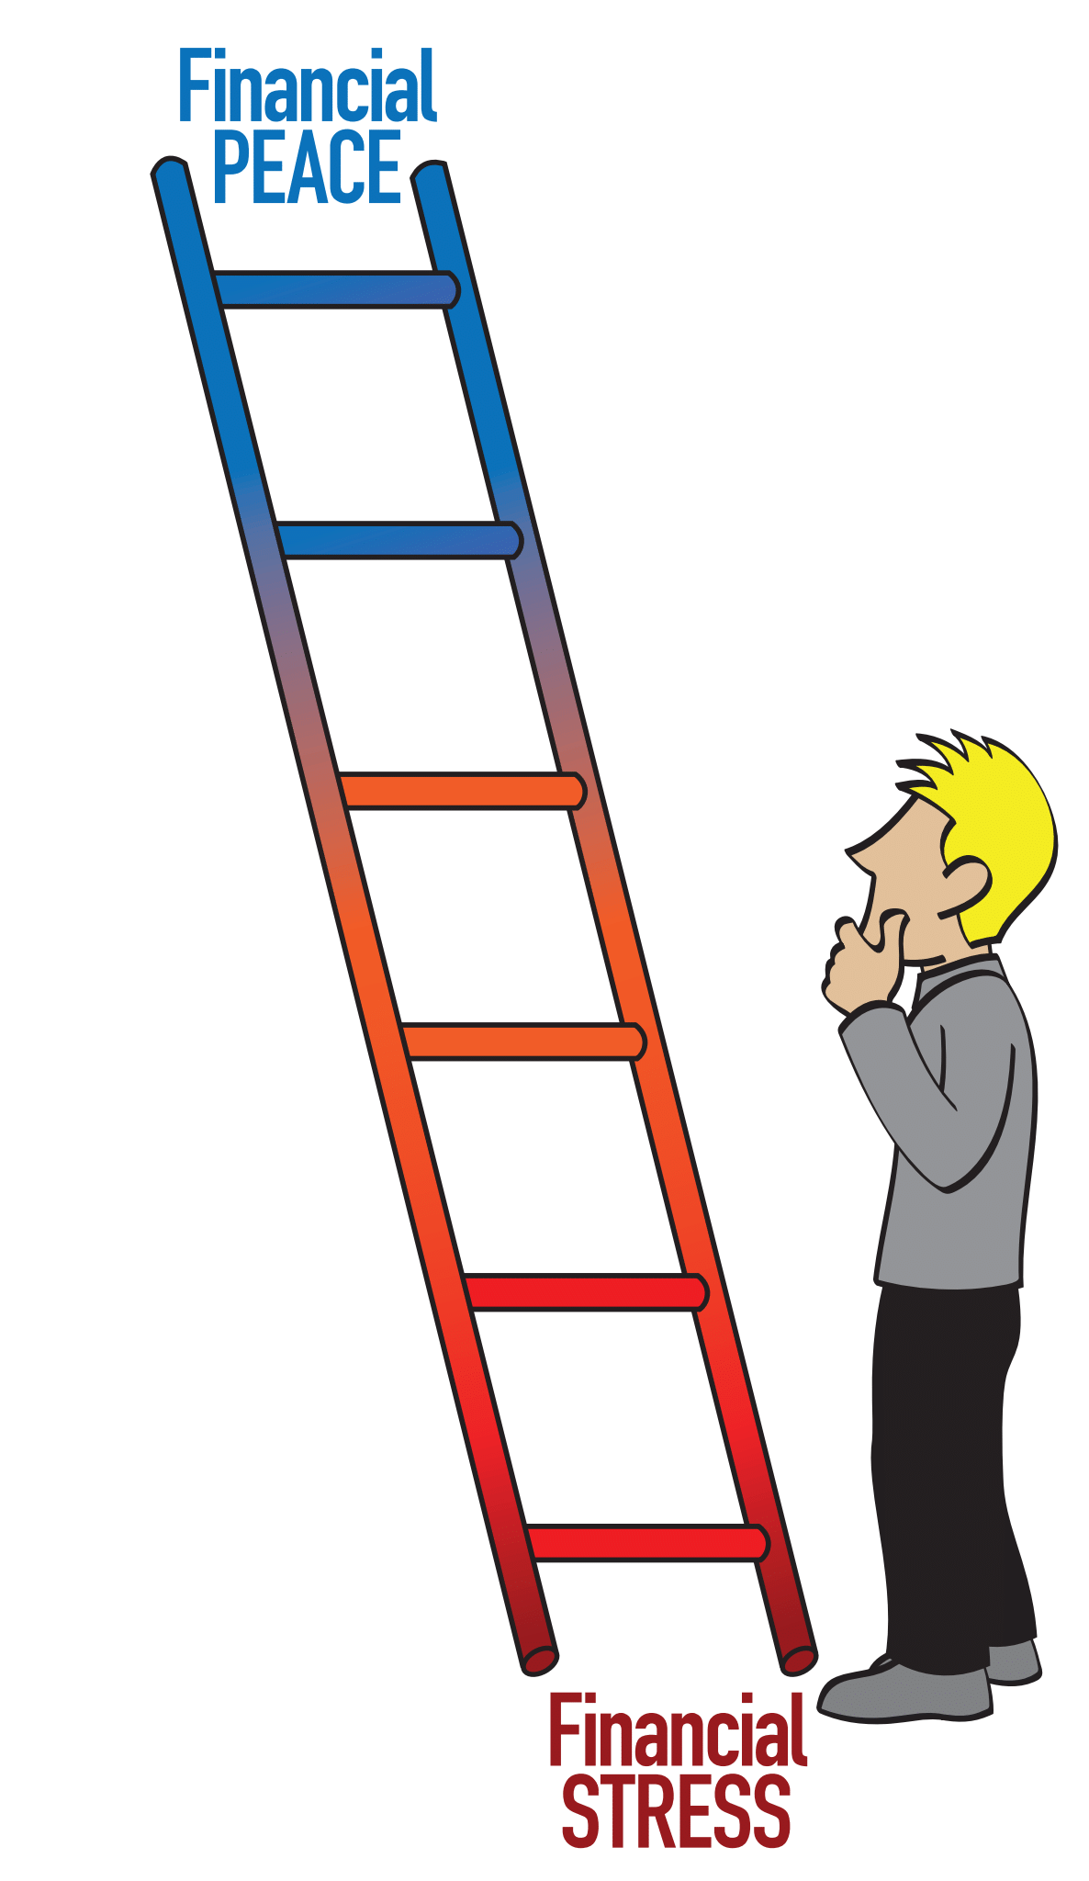

Adapted with permission from *The Generosity Ladder*   
by Nelson Searcy.

[**www.ChurchLeaderInsights.com**](http://www.ChurchLeaderInsights.com)[**www.newlifeelgin.org**](http://www.newlifeelgin.org) **2**

**New Life Community Church Purpose Statement**

New Life Community Church exists to connect people

with Christ and Community

**A NEW PERSPECTIVE**

*“Since you excel in so many ways – in your faith, your gifted speakers,  
your knowledge, your enthusiasm, and your love from us –  
I want you to excel also in this gracious act of giving.”* - 2 Corinthians 8:7

[**www.ChurchLeaderInsights.com**](http://www.ChurchLeaderInsights.com)[**www.newlifeelgin.org**](http://www.newlifeelgin.org) **3**

**GOD AND MONEY**

* 361 verses in the Bible about Love
* 367 verses in the Bible about Prayer
* 500 verses in the Bible about Faith
* ______________ verses in the Bible about Money and Possessions

**A Biblical Understanding of Money Matters!**

1. **GOD** __________ **IT ALL.**

*“The earth is the Lord’s, and everything in it.   
The world and all its people belong to him.”* - Psalm 24:1

1. **GOD ENTRUSTS ME WITH SOME.**

(Jesus) *“Again, the Kingdom of Heaven can be illustrated by the story of a man going on a long trip. He called together his servants and entrusted his money to them while he was gone.  He gave five bags of silver to one,   
two bags of silver to another, and one bag of silver to the last –  
dividing it in proportion to their abilities.”* - Matthew 25:14-15

[**www.ChurchLeaderInsights.com**](http://www.ChurchLeaderInsights.com)[**www.newlifeelgin.org**](http://www.newlifeelgin.org) **4**

1. **ONE DAY GOD WILL AUDIT MY LIFE.**

*“After a long time their master returned from his trip and called them to give an account of how they had used his money.”* - Matthew 25:19

*“Each of us will give a personal account to God.”*   
- Romans 14:12

1. **GOD EXPECTS ME TO BE** __________________ **WITH WHAT I HAVE.**

*“Give freely and become more wealthy; be stingy and lose everything.   
The generous will prosper; those who refresh others will themselves be refreshed.”*- Proverbs 11:24-25

*“Remember this: Whoever sows sparingly will also reap sparingly, and whoever sows generously will also reap generously.”* - 2 Corinthians 9:6

“If those who ‘gain all they can,’ and ‘save all they can,’ will likewise ‘give all they can;’ then, the more they gain, the more they will grow in grace, and the more treasure they will lay up in heaven.” *- John Wesley, Founder of Methodism*

“The measure of a life, after all, is not its duration, but its donation.”   
*- Corrie Ten Boom, Author and Nazi Death Camp Survivor*

“If a person gets his attitude toward money straight, it will help straighten out almost every other area in his life.” *- Billy Graham*

**GOAL FOR THIS SEMINAR:** To become a fully developing follower of Jesus,   
  
I must first become a fully developing ___________________________________.

[**www.ChurchLeaderInsights.com**](http://www.ChurchLeaderInsights.com)[**www.newlifeelgin.org**](http://www.newlifeelgin.org) **5**

**BIBLICAL TRUTH:** _____________________ is _____________________.

[**www.ChurchLeaderInsights.com**](http://www.ChurchLeaderInsights.com)[**www.newlifeelgin.org**](http://www.newlifeelgin.org) **6**

**HOW TO STEP UP TO A LIFE OF GENEROSITY**

*“Whatever is good and perfect is a gift coming down to us from God our Father, who created all the lights in the heavens. He never changes   
or casts a shifting shadow.”* - James 1:17

**BASIC LEVEL: RETURN _________________________________.**

*“On the first day of each week, you should each put aside a portion*

*of the money you have earned.”* - 1 Corinthians 16:1-2

(Jesus) *“Wherever your treasure is, there the desires of your heart will also be.”*

- Matthew 6:21

[**www.ChurchLeaderInsights.com**](http://www.ChurchLeaderInsights.com)[**www.newlifeelgin.org**](http://www.newlifeelgin.org) **7**

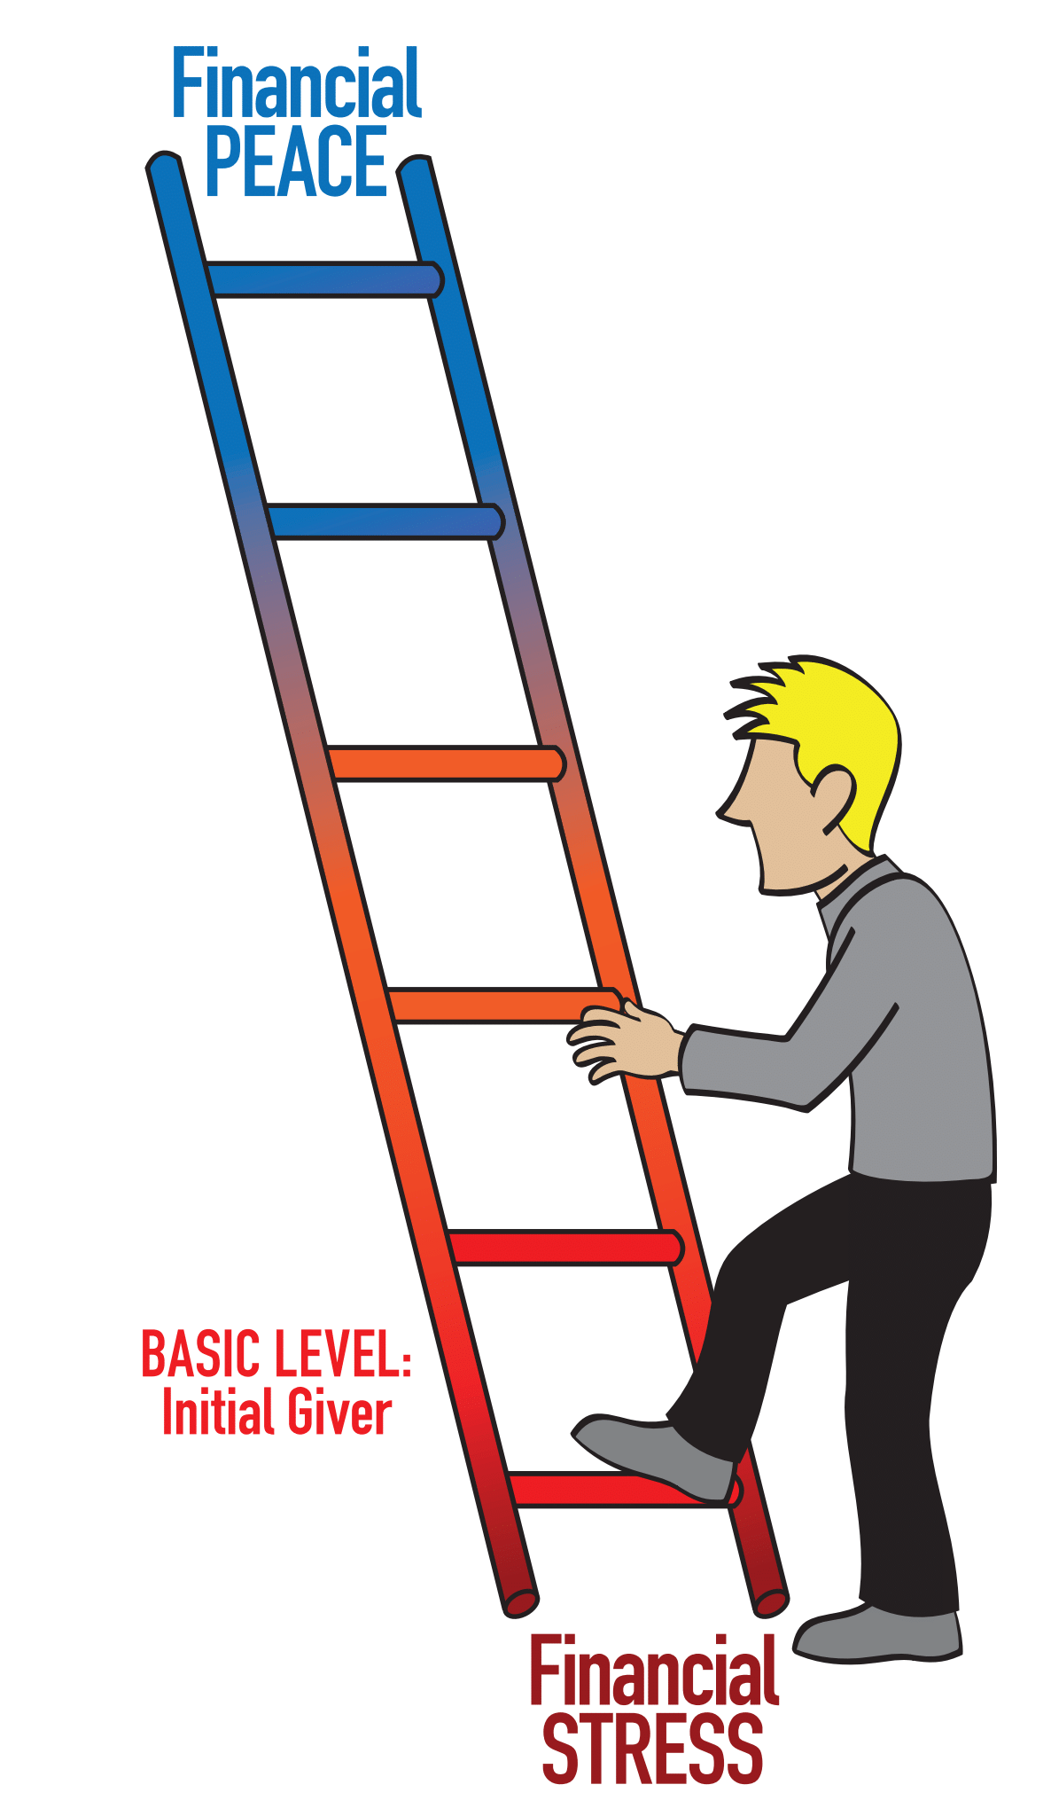

[**www.ChurchLeaderInsights.com**](http://www.ChurchLeaderInsights.com)[**www.newlifeelgin.org**](http://www.newlifeelgin.org) **8**

**OBEDIENCE LEVEL: RETURN** ____________________________**.**

* The Word “Tithe” Means:________________________________

*“Will a man rob God? Yet you rob me. But you ask, ‘How do we rob you?’   
In tithes and offerings. You are under a curse – the whole nation of you – because you are robbing me. Bring the whole tithe into the storehouse, that there may be food in my house. ‘Test me in this,’ says the LORD Almighty, ‘and see if I will not throw open the floodgates of heaven and pour out so much blessing that you will not have room enough for it.’”* - Malachi 3:8-10

What’s the Difference Between Tithes and Offerings?

* A tithe is giving God the first______________________________**.**
* An offering is anything I give______________________________**.**

Where Should I Tithe? __________________________________

*“When it was time for the harvest, Cain presented some of his crops*

*as a gift to the LORD.”* - Genesis 4:3

*“Honor the Lord with your wealth and with the best part of everything you produce. Then he will fill your barns with grain,  
and your vats will overflow with good wine.”* - Proverbs 3:9-10

[**www.ChurchLeaderInsights.com**](http://www.ChurchLeaderInsights.com)[**www.newlifeelgin.org**](http://www.newlifeelgin.org) **9**

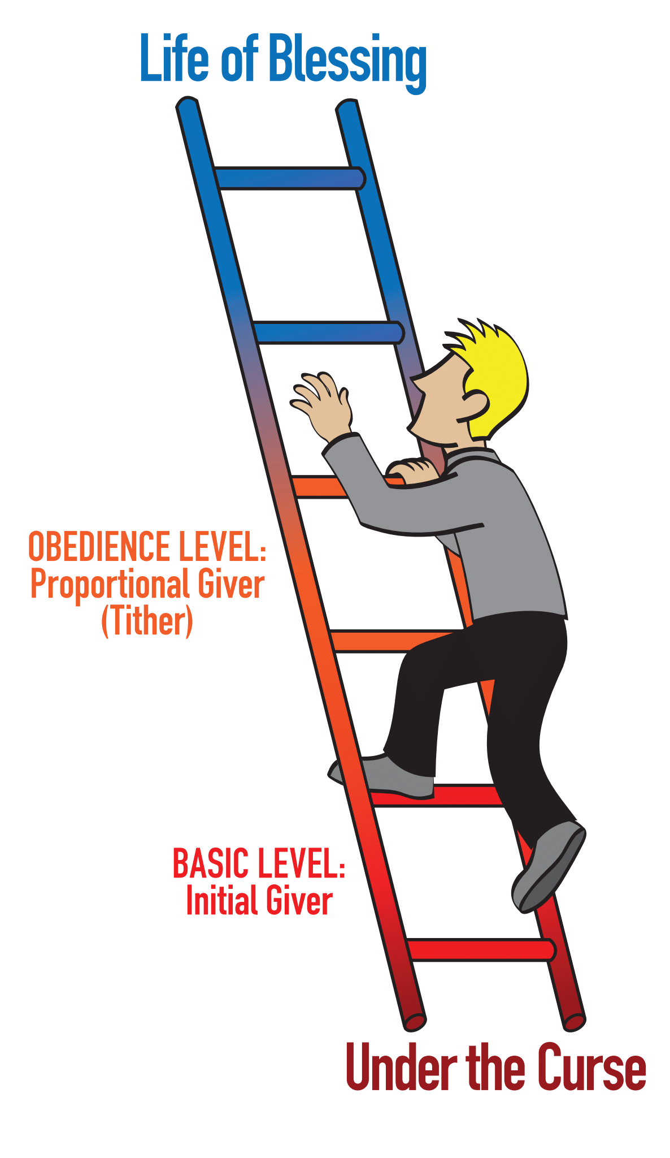

[**www.ChurchLeaderInsights.com**](http://www.ChurchLeaderInsights.com)[**www.newlifeelgin.org**](http://www.newlifeelgin.org) **10**

**The Tithing Debate: Legalism vs. Grace in Giving**

(Jesus) *“Don’t misunderstand why I have come. I did not come to abolish the law of Moses or the writings of the prophets. No, I came to accomplish their purpose.**I tell you the truth, until heaven and earth disappear, not even the smallest detail of God’s law will disappear until its purpose is achieved.**So if you ignore the least commandment and teach others to do the same, you will be called the least in the Kingdom of Heaven. But anyone who obeys God’s laws and teaches them will be called great in the Kingdom of Heaven.”* - Matthew 5:17-19

**The Israelites’ Tithes Often Amounted to** _____________ **of their Income.**

**The Average Christian Gives** ______________ **of their Income**

“When we as New Testament believers, living in a far more affluent society than ancient Israel, give only a fraction of that given by the poorest Old Testament believers, we surely must reevaluate our concept of grace giving.” - Randy Alcorn, *Money, Possessions, and Eternity*

**At New Life Community Church over the last 5 years…**

* **___________% Have Not Given at All.**
* **___________% Have Given Something, But Not a Full Tithe.**
* **___________% Give a Full Tithe.**

(Jesus) *“Yes, you should tithe, and you shouldn’t leave the more  
 important things undone either.”* - Matthew 23:23

[**www.ChurchLeaderInsights.com**](http://www.ChurchLeaderInsights.com)[**www.newlifeelgin.org**](http://www.newlifeelgin.org) **11**

**PEAK LEVEL: BECOME** _______________________________________**.**

*“Jesus sat down near the collection box in the Temple and watched as the crowds dropped in their money. Many rich people put in large amounts. Then a poor widow came and dropped in two small coins. Jesus called his disciples to him and said, ‘I tell you the truth, this poor widow has given more than all the others who are making contributions. For they gave a tiny part of their surplus, but she, poor as she is, has given everything she had to live on.’”* - Mark 12:41-44

*“You must each decide in your heart how much to give. And don’t give reluctantly or in response to pressure. ‘For God loves a person who gives cheerfully.’”*    
- 2 Corinthians 9:7

*“You should remember the words of the Lord Jesus:*

*‘It is more blessed to give than to receive.’”* - Acts 20:35

(Jesus) *“The master said, ‘Well done, my good and faithful servant.   
You have been faithful in handling this small amount, so now I will give you   
many more responsibilities. Let’s celebrate together!’”* - Matthew 25:23

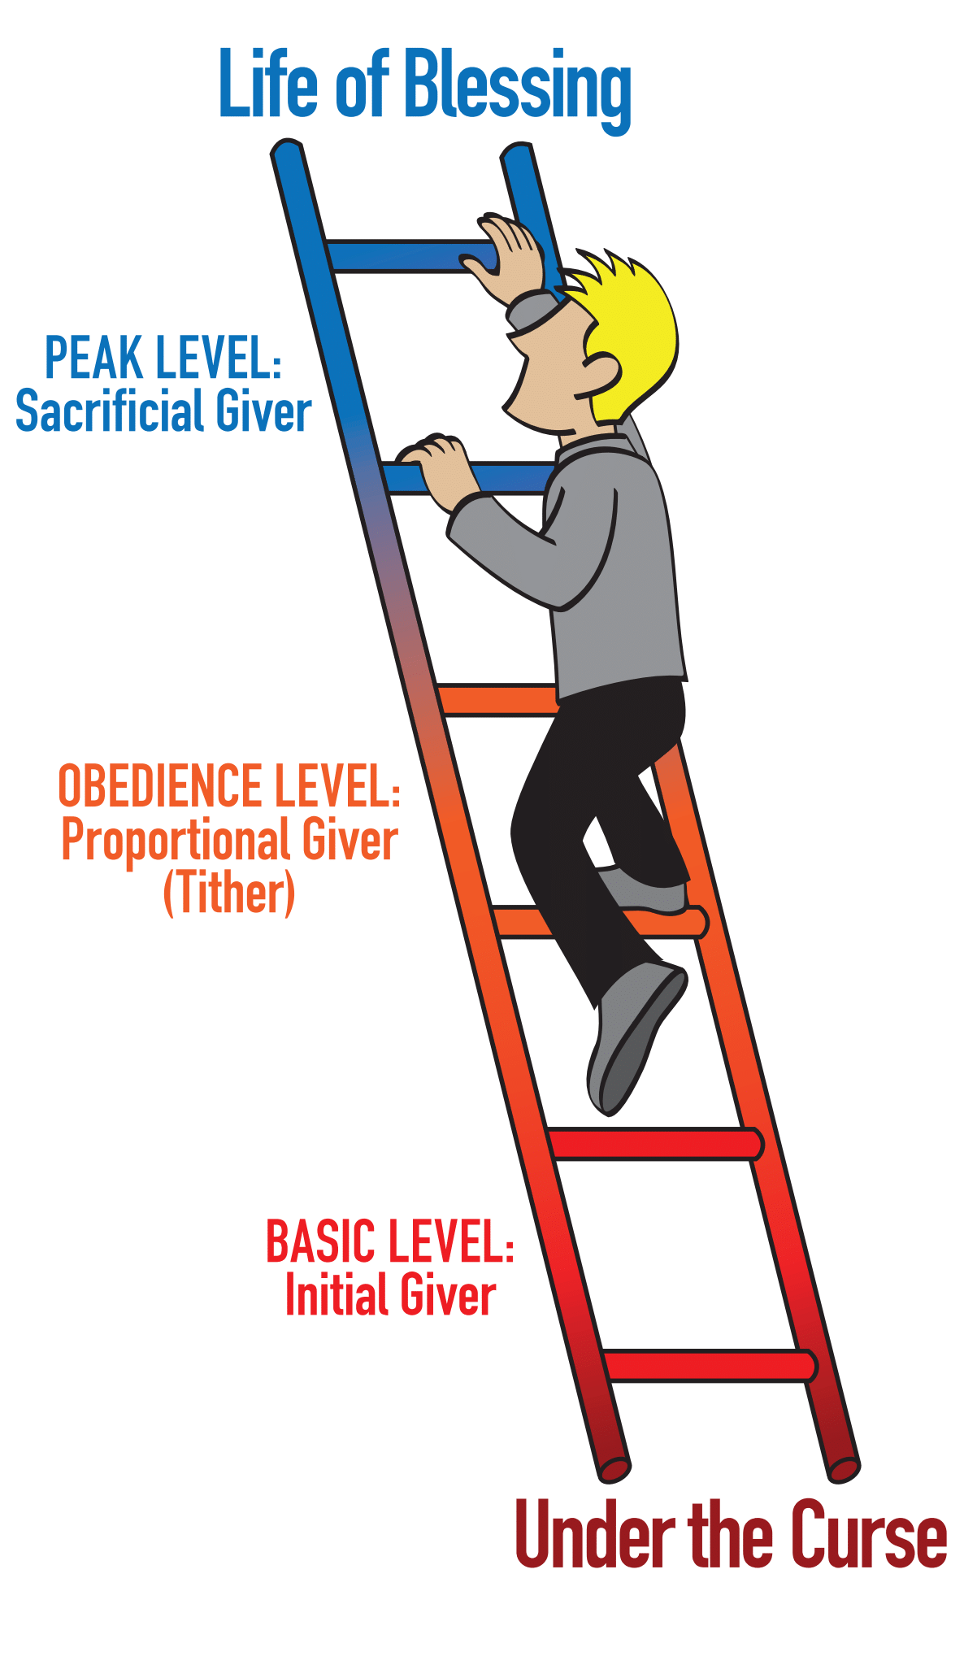

[**www.ChurchLeaderInsights.com**](http://www.ChurchLeaderInsights.com)[**www.newlifeelgin.org**](http://www.newlifeelgin.org) **12**

**GIVING WORKSHEET:**

How much do I make in a year (before taxes)? $ _______________________

My yearly tithe should be (10%): $ ______________________

How much do I make in a month (before taxes)? $ _____________________

My monthly tithe should be (10%): $ _____________________

How much will I commit to give sacrificially/extravagantly this year:

* ______________% above my regular tithes and offerings.

or

* $______________ above my regular tithes and offerings.

**MY NEXT STEP TODAY IS TO:**

* Bring an initial gift back to God.

* Become a consistent giver by automating my giving.
* Take the 6-Month Tithe Challenge.

* Give sacrificially this year over-and-above my tithe.

Commit to be a life-long steward of God’s resources.

[**www.ChurchLeaderInsights.com**](http://www.ChurchLeaderInsights.com)[**www.newlifeelgin.org**](http://www.newlifeelgin.org) **13**

* **FOR FURTHER STUDY:**
* Bible verses on giving, generosity and godly money management:
  + Matthew 6:21
  + Malachi 3:8-10
  + Ecclesiastes 5:10
  + Romans 13:8
  + Psalm 37:16-17
  + Psalm 13:11
  + Hebrews 13:5
  + Matthew 19:21
  + Proverbs 17:16
  + Matthew 6:24
  + Luke 3:14
  + 1 Timothy 6:6-10
  + 1 Timothy 6:17-19
  + Deuteronomy 15:7
  + Matthew 6:1-4
  + Mark 12:41-44
  + Luke 16:13-15
  + Proverbs 3:9-10
  + 2 Corinthians 8:7
  + 1 Corinthians 16:1-2
  + Matthew 23:23
  + 2 Corinthians 9:7
  + Acts 20:35
* *Money, Possessions & Eternity* – Randy Alcorn

* *The Treasure Principle* – Randy Alcorn
* *The Generosity Secret* – Nelson Searcy
* *The Generosity Ladder* – Nelson Searcy
* *The Money Challenge for Teens* – Art Rainer
* *Money Matters* – Larry Burkett

[**www.ChurchLeaderInsights.com**](http://www.ChurchLeaderInsights.com)[**www.newlifeelgin.org**](http://www.newlifeelgin.org) **14**