Week One: Beautiful Creator By Zach Adams (Norwood Park)
INTRO (for leaders):
When thinking about God as a creator, people often focus on how this shows his glory, power, and majesty. Or people focus on the science of it all: did God create the world in 7 days, or billions of years? Was evolution involved or not? While these questions are important, we often overlook a truth about our Creator that can change the way we see everything. It could change the way we live our lives. That’s the truth that God is a beautiful creator. God is beautiful, and he can’t help but make beautiful things. That truth has a ton of implications for us! The world is beautiful, God is beautiful, we are beautiful, our bodies are beautiful, creativity and art are important, etc. God cares about the big things, he cares about the little things. It’s good to delight in these things too.

Intro to message: What is the most beautiful place you’ve ever seen?
- [After allowing the students to share for a bit or shout out places, share an example of your own. Maybe point out how even places in the city can be beautiful, so as not to leave out kids that may have never traveled before. Showing pictures of beautiful places would be a nice touch!]
- Have you ever heard of a “Kodak Moment?” People used to say that phrase when there was a moment so good that you had to get a picture of it.
- When we see something that is beautiful, we experience a feeling of awe and wonder. We want a way to revisit that memory of wonder throughout our lives, because in our daily lives we can forget about those moments. But we don’t have to live that way, we can look for the beauty all around us, because it’s there. But how can we do that?
- We’re starting up a new series today called Who is God? We talk a lot about God at church, but we can sometimes lose sight of who God really is. What makes God so special? In this series, we want to get to know God in a personal way and we’ll be doing that by focusing on four of God’s attributes. DEFINITION: An attribute is a characteristic or trait that helps us to know who God really is and what he is like. Like some of you are funny, or kind, or creative, God has attributes too. Today we’re talking about how God is a beautiful creator.

Our Big Idea is that Because God is a beautiful creator, he only creates beautiful things.

- God created everything beautiful (read Genesis 1:1-5, or the whole chapter if you think your students can handle that. I recommend reading the first few verses, then summarize the rest of the days of creation, then read Gen 1:31)
- When you read Genesis 1, you might notice that there is a pattern to the story of creation. The pattern goes: God said “let there be”→ God saw that it was good. → and God called it ____ . I want to draw attention to a specific phrase here, “God saw that it was good.”
- Whenever God makes something in Genesis 1, he takes time to look at it, and appreciate its beauty. He sees that it is good–according to his design.
- When God looked at his work at the end of each day of creation, he looked for a moment and thought, “Wow, that’s beautiful!” That’s some good stuff! This is a kodak moment.
- Just like you, he looked at the stars and said, “Wow!” He saw the mountains he had made, the deep canyons, the oceans and waterfalls and was blown away by their goodness and beauty. He saw the flowers, the plants, the great diversity of the animal kingdom, and he was delighted at their splendor.
- But it wasn’t just these great vast things that God delighted in.
    - You see, the phrase “God saw that it was good” repeats 7 times throughout chapter one, but in one verse there’s a slight change. At the end of day 6, in v. 31 it says, “God saw all that he had made, and it was very good.” Creation went from “good” to “very good”!
    - What changed on the sixth day to upgrade creation from “good” to “very good”? The answer is in v. 27: “God created humankind in his own image, in the image of God he created them; male and female he created them.”
    - It was humans! God saw a beautiful creation and said, “Wait up, I know what will make this complete. I know what will bring this all together.” And God created his masterpiece: human beings. You and me.
    - So God delights in landscapes and constellations, but he also looks at us and delights in the beauty he created in us. You are beautiful. Your creator thinks you are beautiful. Do you agree with Him?
    - Most of us struggle to look at ourselves and think that we are beautiful? How many of us struggle to accept that God has created our physical bodies beautiful. These bodies that we are insecure about; these bodies that have been hurt by others; these bodies that have scars. These bodies that we think are ugly are beautiful because God has created us beautiful. Do you believe that? That God thinks you are beautiful? He does! He delights in you.
- Illustration: Shedd Aquarium has art pieces made from pieces of trash found in the ocean. Where many people see a bunch of trash, an artist was able to see the potential for beauty. [Pictures below at end of outline or download them from the site]
- Implications
- God does not make mistakes. He doesn’t make trash. He doesn’t make things that aren’t good and beautiful. That’s because God himself is beautiful and all of the beauty we see in the world is just a tiny reflection of his own vast beauty.
- Turn to the person sitting next to you and tell them, “You’re beautiful.” Yes, even the guys!

Transition: God made everything beautiful and good, but you might be wondering, “If God made the world so good and beautiful, why does it seem so messed up now? If God made me beautiful, why don’t I feel that way about myself?” That’s a great question. The answer is that people traded beauty for destruction.

II. Humans traded beauty for destruction
- God made a beautiful home for us to live in together with Him, for all of creation to thrive in its beauty, but the story continues in chapter 3.
- Many of you have heard the story before. Satan deceived Adam and Eve into believing that they could create a more beautiful way of life without God. So they turned their backs on God and introduced sin into the world, which made a mess of it all.
- Illustration: Couple different options for illustrations: 1) A personal story: For example, a few years ago, California experienced a superbloom of poppy flowers in the hills near where I’m from. So many people hiked up to go see the beauty of these flowers, but many people just wanted to get Instagram photos with them and not to admire and respect their beauty. This got to the point where officials had to close off whole sections and to shut trails down because the flowers had been trampled and broken down and needed to heal. The sign read, “Trail closed for flower rehabilitation.” You never really think of flowers needing rehab! Do you have a story of a time you saw beauty tarnished? You can use this story or your own.
2) Like when you see a really cool mural but someone has graffitied over it. 3) Like when people went into art museums and threw tomato soup all over masterpieces like the Mona Lisa and Van Gogh’s painting. (Here’s a link if you’d like to learn more about this story before using it: Van Gogh– and Mona Lisa)
The point of the illustration: People took something that was beautiful, what God had intended for life and goodness, and decided to act in destructive ways

- It gets so bad that eventually it says in Genesis 6:12, “God saw how corrupt the earth had become, for all the people on earth had corrupted their ways.”
- At creation, God looked and saw a very good and beautiful creation, but because of people’s sin, God looks now and sees a corrupted creation. This is all because people decided to be destructive and violent.
- Implication: Before we think we’re off the hook because our sin isn’t “that bad”
We often take part in this violence too (Take a moment to think through examples for each of these that would apply and resonate to your students)
- Violence to ourselves
- The terrible things we say to ourselves, our insecurities, our toxic thoughts, our self-harm, self-medication, staying in unhealthy situations.
- Violence to people around us
- The way we hurt people and tear them down with our words, or talk about people in ugly ways, or act selfishly, taking part in drama, leading people on, getting into fights, demeaning other people, racist comments, we bully others or ignore it when others are being bullied, etc.
- Violence to God’s creation
- This is one we don’t think about a lot, but we often live our lives without thinking about how it affects the beautiful natural world that God has put us on to take care of. We litter, we eat unhealthy food, we live wasteful lives.

Transition: This is what human beings have done to God’s beautiful creation. We have traded beauty for destruction. But there is another way. We’ve been talking about how because God is a beautiful creator, he only makes beautiful things (Big idea). So how does the beautiful creator still work in a messy, violent world?

III. God is making all things beautiful again.
God is not like us. When something is broken we throw it away. Many of you have tried to create something–a song, a painting, a drawing, a video, etc. and because it didn’t turn out well you may have abandoned the project. So what does God do when creation goes off track?
God never abandons his beautiful creation. Instead, he’s taking the mess we’ve made and makes all things beautiful again.
2 Corinthians 5:17-19 says, “17 Therefore, if anyone is in Christ, that person is a new creation. The old has gone, the new is here! 18 All this is from God, who reconciled us to himself through Christ and gave us the ministry of reconciliation: 19 that God was reconciling the world to himself in Christ, not counting people’s sins against them. And he has committed to us the message of reconciliation.”
What is God’s answer to the messiness of the world? Jesus. You see, God did not abandon us in our destruction and corruption, but he joined creation by sending his son as a physical human being, to live a life of beauty and to die in our place so that we can be restored to beauty and a relationship with the beautiful creator.
Where humans take beautiful things and destroy them, God takes broken things, and makes them beautiful.
Illustration: Japanese art style: Kintsugi (Illustration inspired by Makoto Fujimura, a Christian artist)
- Makoto Fujimura. Show images of kintsugi bowls included below. There is an art form called Kintsugi where artists will take broken vessels, like vases or bowls which are no longer worth anything to people, and put them back together, lining the cracks with gold. The result is a beautiful and valuable piece of art.
- The vessel is much more valuable and beautiful than it was before it was broken. Not because it was broken, but because a skilled artist with vision took the broken pieces and instead of throwing them away, took them and made them into something new, lining the cracked edges with gold to bring beauty in the exact places of brokenness. Because God is a beautiful creator, no one is so shattered that they cannot be healed and made new.
Implications
- No matter your mistakes, no matter how you feel about yourself, no matter what you have experienced that makes you feel that you are ugly and forgotten, God sees you as beautiful and worth saving. And he wants to make you new.
- And then he wants you to go and tell others about this beautiful good news–about the beautiful creator.
- God doesn’t just want to make you new, he wants to make the entire world new! Nature will not always be suffering from pollution and destruction. There is hope. And he wants to make your friends new too.
Implications/Take away–Because God makes beautiful things in a violent world, we should too.
- Love what is beautiful: Look for the beauty in the world and say “it is very good” like God does!
  - Our places (nature, our homes, the city, etc.)
  - Our faces (Our bodies are beautiful)
  - Our planet (Don’t pollute)
  - Our God (worship and delight in him)
- Create what is beautiful: (or do what is beautiful)
  - Art is important in God’s eyes–be creative!
  - Love is the most beautiful thing. Love others!
- Become what is beautiful: (or be what is beautiful)
  - God has made you beautiful, don’t surrender to the violent ways of the world.
  - Let God love you. Let God mold you and make you new, into an even more beautiful creation that bears his image and his name (Gospel as new creation). If not everything in your life is beautiful right now, then God isn’t done with you!

Possible Discussion Questions:
- What are some examples of beauty you've encountered in your life? Are you an artist? Do you have a favorite artist?
- Have you ever experienced a situation where beauty was tarnished or destroyed by human actions? How did it make you feel?
- How does sin distort our perception of beauty, both in ourselves and in the world around us?
- How can we embrace the idea that God sees us as beautiful, even when we struggle to see it ourselves?
- What are some ways we can reflect God's creativity and beauty in our own lives, relationships, and communities?

- What does it mean to say that God is a beautiful creator? Have you ever thought of God this way? How does this idea shape your understanding of God?
- Why do you think God took time to appreciate his creation after each step of the creative process?
- How does the phrase "God saw that it was good" reflect God's attitude toward his creation?

Shedd Aquarium Art Pieces from Trash:
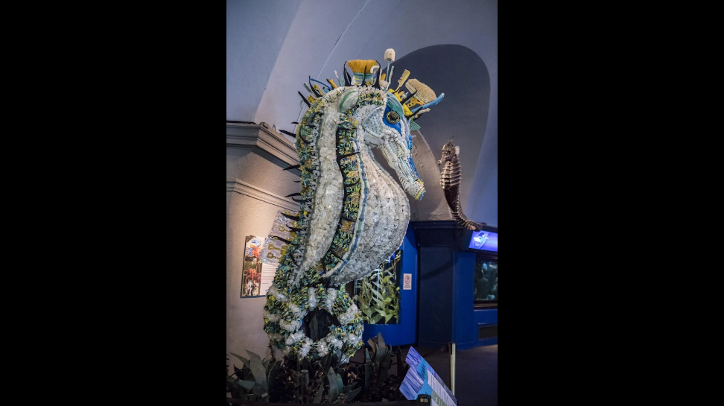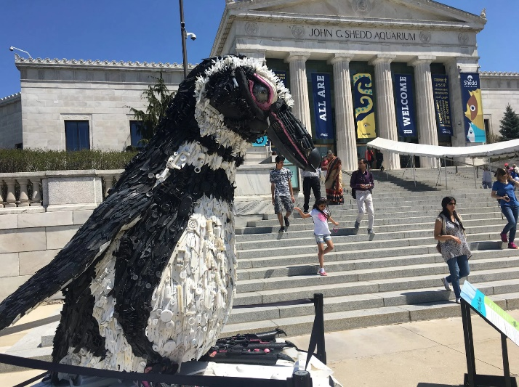
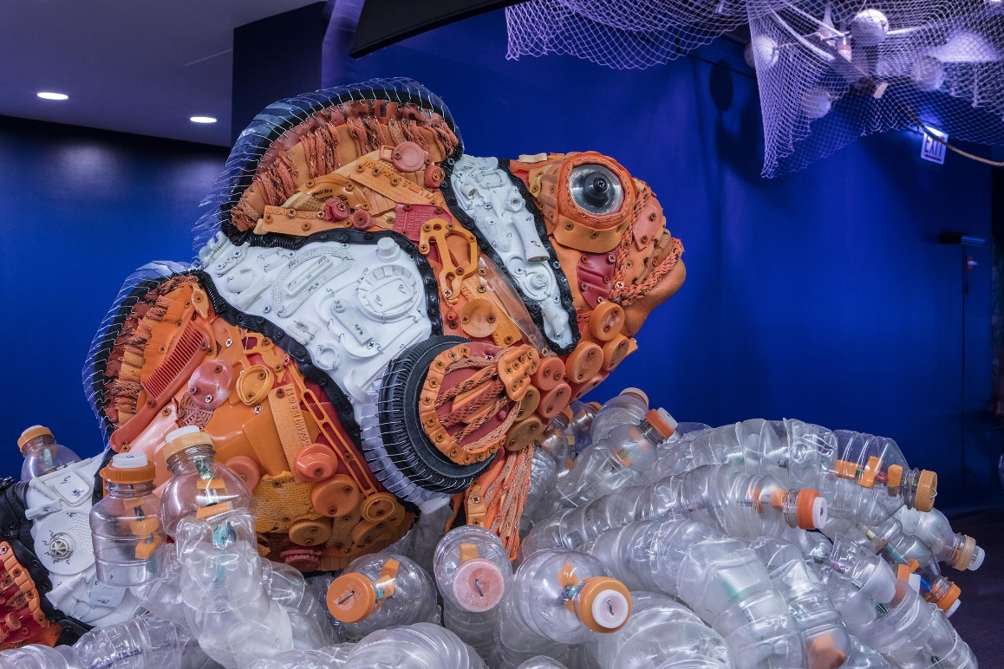

Kintsugi Bowls
