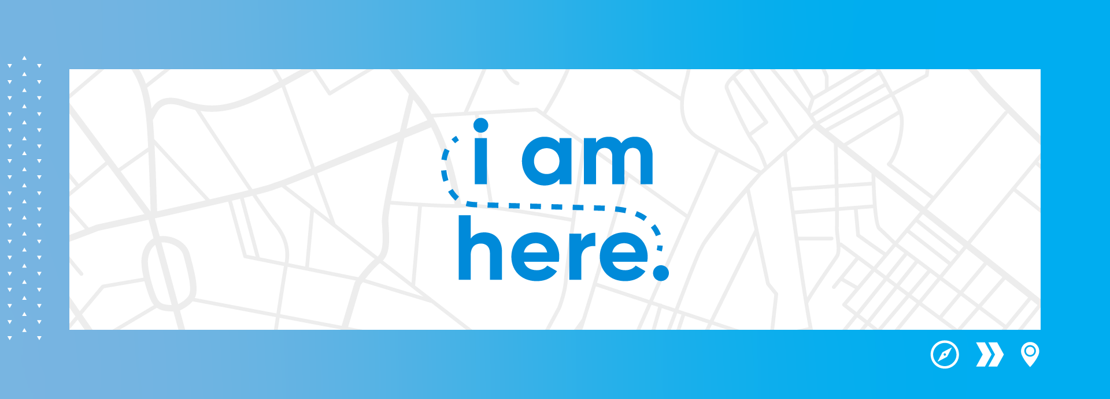

 | PASTORS | MEDIA | LOCATION ADMIN
3 weeks out: July 25 | Meet with team to intro campaign. | Publish admin website.  Order materials. | Order necessary materials for interaction walls.
2 weeks out:  August 1 | Choose members of your church that could share their story in a short video. | Mock website, app setup, Facebook. | Assign team members to assemble and “man” the interaction stations.
3 weeks out:  August 8 | Announce upcoming campaign to congregation. | Publish campaign on website and app.  Distribute materials to locations. | Include campaign in the weekly guide. Send out an email to congregation about the campaign.
Begin: August 15 | Announce campaign start and that it is leading up to the rally series and encourage people to interact physically and digitally. | Play bumper video.  Social media #1-3.  Take photos at locations! | Physical interaction walls up, have someone at the wall, and someone to take photos!  Campaign in the weekly guide.
August 22 | Remind about campaign and to interact with the physical station. | Social media #4-7.  Repost stories.  Take photos! | In the weekly guide.  Take photos and videos at the interaction wall!
August 29 | Reminder to interact physically and digitally. Remind about Rally series! | Social media #8-11.  Repost stories!  Take photos!

