January 14-15 | CAMP WONDERLAND | 9241 Camp Lake Road, Camp Lake, WI 53109

SATURDAY, JANUARY 14
10:00 AM Worship and tech team arrives to set up chapel
11:00 AM Students arrive and check in to cabins
12:00 PM Lunch in Dining Hall
1:30 PM Games in Sharp Center, tubing hill optional
4:30 PM Back to cabins to change
5:30 PM Dinner in Dining Hall
7:00 PM Main Session in Wonderland Chapel
9:30 PM Drinks, snacks, and pizza
10:00 PM Talent Show in Upper Chapel
11:00 PM Back to cabins
Midnight Lights out

SUNDAY, JANUARY 15
7:30 AM Breakfast in Dining Hall
9:30 AM Session 2 in Wonderland Chapel & Group Time
12:00 PM Lunch in Dining Hall
1:30 PM Games in Sharp Center, Rock climbing
3:30 PM Closing Session in Sharp Center
4:30 PM Dismissal

CAMP WONDERLAND MAP

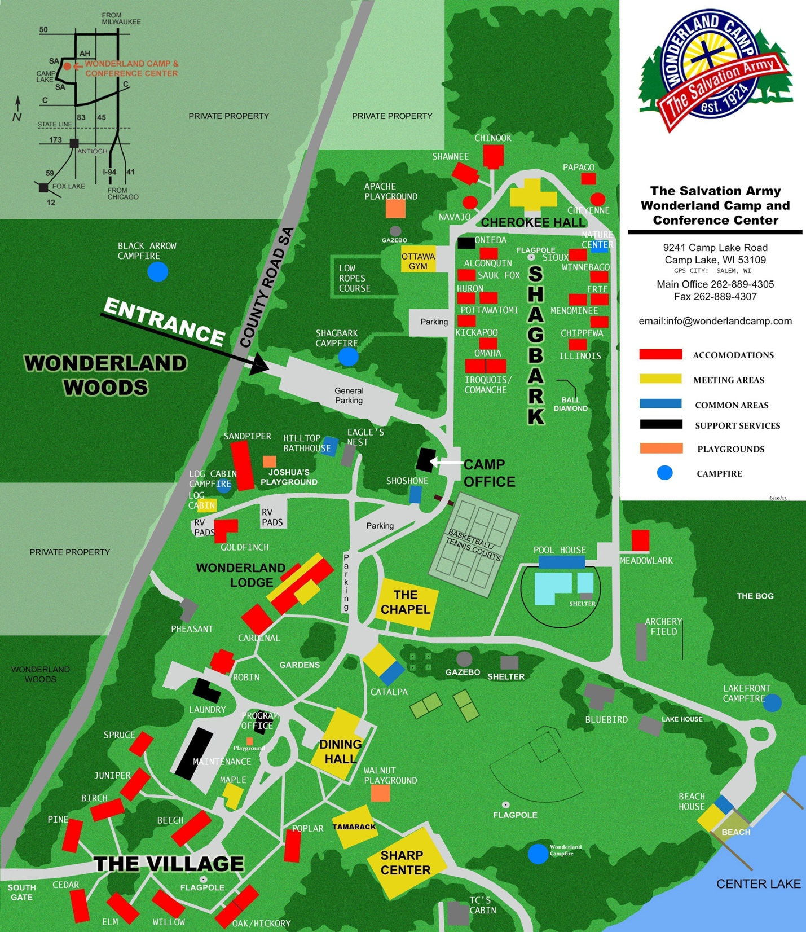

EMERGENCY CONTACT LIST
Nurse:
Security:
Help Desk:

Please visit Help Desk for questions, supplies, or support.

PACKING LIST

- Toothbrush and toothpaste
- Deodorant
- Body Wash
- Shampoo/Conditioner
- Shower Caddy
- Bath Towels
- Washcloth
- Prescription Meds
- Sleeping bag/sheets/blankets
- Pillow
- Water bottle
- Phone charger (if needed)
- Pen/Pencils
- Bible
- Journal
- Cash for concessions and merch
- Comfortable clothes and shoes

MERCH PRICE LIST COMING SOON!

