Do you know where you are?

As you come out of a long, hard, and disorienting season, it can be difficult to know just where you are, where you’ve been, and where you’re going. This past year has given you a story, and at New Life we believe that your story matters. That’s why our “I Am Here” campaign is all about sharing our stories. But processing your own story, let alone sharing it with others, takes time and effort. This reflective guide is a tool to help guide you through the understanding and sharing of your story by thinking through the 10 questions below.

- As if in a timeline, list the major events or key moments of your life that occurred during the past year, both positive and negative.
- When you look at the events listed above, what emotions do you feel? Name 3-5 most prominent emotions or feelings. The wheel below shows common emotions, use this as a reference if you need!

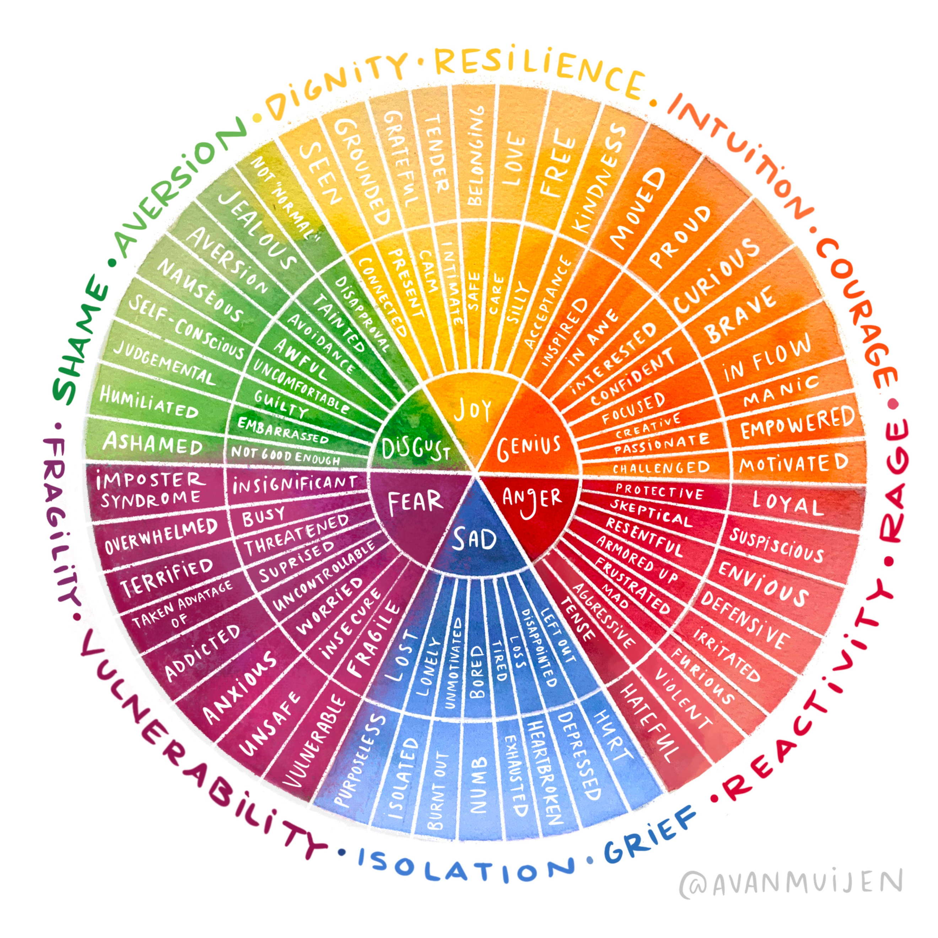

- After this year, is there anything that is missing from your life? Either physically, mentally, or emotionally?
- Is there anything new in your life that was added in this past year?

- What is your most difficult experience from this past year?
- What is your happiest or most joyful memory from this past year?

- What have you overcome in this past year? How did you overcome that thing(s)?
- In what ways have you changed over this year, for better or worse?

- How have you seen God working in your life over the past year?
- What has been a key scripture or verse that has encouraged you this past year? What verse could be an encouragement to you in the next season?

Next, here are some practices and steps you can take to begin sharing your story and moving forward in hope into the next season.

- Consider sharing your story or parts of it with a friend or loved one this week.
- Reflect on the verse that you chose as an encouragement and guide for this next season. Spend some time in prayer asking God how he wants to work in you moving forward.
- Consider ways that you can interact with our I am here campaign and share your story with your community at New Life either on social media or in person at your location.

Your story is an important part of your presence at New Life, and we are so happy you are here.

