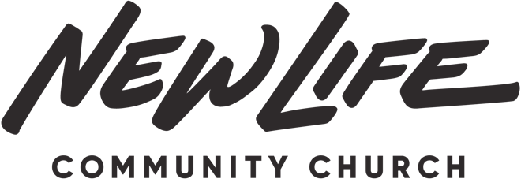

Pastoral Covenant 2022

Initial next to each item (“I have read and affirm”)

_____ I understand and agree with New Life’s statement of faith and vision statement and have no significant discrepancies.

_____ I understand the priority and relational value of our pastoral team meetings and agree to make every effort to be present and fully participate.

_____ I understand the need to live above reproach and to agree to uphold the qualifications of a leading Elder.

_____ I understand New Life’s culture of cooperation and desire to bless other life giving ministries and agree to be an extension of that culture.

_____ I understand the importance of ministry as a pastoral couple and agree to support and encourage my wife’s use of her gifts and participation in the pastor’s wives gatherings.

_____ I understand the vision of being a part of a movement church that multiplies regularly and agree to do what is in my power to follow that pattern.

_____ I understand that New Life is one church that meets in multiple locations so I agree to participate in unified teaching series, discipleship process, leadership training and all church events.

_____ I understand the importance of setting an example in my giving and generosity and agree to consistent tithing.

_____ I understand the importance of staying spiritually healthy so I agree to prioritize a consistent time each day for the Word and Prayer.

_____ I understand the centrality of the Gospel and therefore I agree to Gospel saturated preaching that both calls people to Christ and teaches them how to live out their new life.

Pastor Name Signature Date

______________________________________________________________________

Wife Name Signature Date

______________________________________________________________________

Elder Covenant 2022

*In addition to the New Life Membership Covenant the Elder agrees to these commitments:

Initial next to each item (“I have read and affirm”)

_____ I understand and agree with New Life’s statement of faith and vision statement and have no significant discrepancies.

_____ I understand the priority and relational value of our Elder team meetings, services and campaigns and agree to make every effort to be present and fully participate.

_____ I understand the need to live above reproach and to agree to uphold the qualifications of an Elder.

_____ I understand New Life’s culture of cooperation and desire to bless other life giving ministries and agree to be an extension of that culture.

_____ I understand the importance of ministry as an Elder/Elder Couple and agree to support and encourage my wife’s use of her gifts (according to the season of life she is in).

_____ I understand the vision of being a part of a movement church that plants churches together and agree to leverage my leadership towards that effort.

_____ I understand that New Life is one church that meets in multiple locations so I agree to participate to the best of my ability in unified teaching series, discipleship process, leadership training and all church events.

_____ I understand the importance of setting an example in my giving and generosity and agree to consistent tithing.

_____ I understand the importance of staying spiritually healthy so I agree to prioritize a consistent time each day for the Word and Prayer.

_____ I understand the centrality of the Gospel and therefore I agree to Gospel saturated preaching and teaching that both calls people to Christ and teaches them how to live out their new life.

Elder Name Signature Date

______________________________________________________________________

Wife Name Signature Date

______________________________________________________________________

