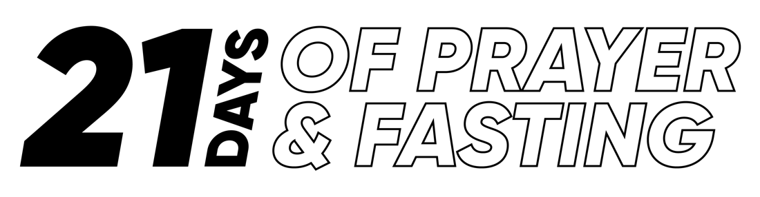
A GUIDE TO PRAYER & FASTING

BEFORE FASTING...

Why fast?
On top of being a great practice to purify our bodies, in Matthew 6:16-18 Jesus referred to Fasting as a normal expectation for each of his disciples. In Galatians 5:16 the Apostle Paul challenges believers to be led by God’s spirit instead of being guided by the natural desires of our body.

What is a fast?
According to the dictionary, the word “fast” means “to suffer hunger” or “abstain from food or drink”. There are hundreds of Bible verses that talk about fasting. Meditate on these: 1 Corinthians 9:27, Esther 4:16, Jonah 3:5-9. The purpose of fasting is to create a space of time for developing spiritual intensity for pursuing closeness with God. For this reason, fasting without prayer is not a biblical activity.

It is important to mention that a true fast always involves abstaining from food. That is why someone who chooses to abstain from Facebook, shopping or “giving up chocolate” is not necessarily fasting. Fasting is not a means to manipulate God. Some people mistakenly think that if they fast then God owes them a favor. We do not fast to force the hand of God to do our will but to draw closer to him and to be more available to hear his voice.

What should the main goal for my fasting be?
The main goal for fasting should be to get closer to God. In Amos 5:4 God challenges his people to “seek me and you will live.” It is good to fast for urgent prayer requests but it’s essential to set our hearts on seeking God first, above all other pursuits of our heart.

What types of fast do we do at New Life?
Although the Bible mentions all kinds of fasts, at New Life we encourage our members to do a liquid fast. For this type of fast we give up all types of solid food and ingest only liquids such as juices, broth, and water. We also remove any kind of extra activities that are not essential to our daily responsibilities such as drinking coffee, going shopping, Facebook, and other forms of entertainment.

How do I get ready for my fast?
- Decrease your food intake progressively get rid of non-essentials such as caffeine, soda, sugars, snacks, etc.
- Go shopping for fruits, vegetables, juices and water, before your fast. That way you will avoid store distractions during your fast.
- Free up your calendar in order to make space for intentional times with God ahead of time.
- Lastly, set some clear fasting goals for yourself. How many days will you fast? Which foods? Where will you pray? When will you pray?

What if I have physical ailments that prevent me from fasting?
If you have a medical condition that keeps you from fasting, consult with your physician first. Having said this, you must also understand that fasting will force you to decide between normal things in your life, which are not essential, and the choice of seeking for God sacrificially. Anyone can leave caffeine, gossip radio, talk shows, computer games and junk foods without a doctor’s permission.

What if my job is physically demanding?
Thousands of Christians throughout history and across the world living under extreme pressures find times for fasting. Remember that God invites you to draw near Him (James 4:8). You should evaluate the demands of your job and seek to give your best regardless of whether you are fasting or not. Since all we do is a reflection of God’s work in us, our job performance is an essential part of our personal witness. For that reason, we ask that you not mindlessly put your life in danger without clear conviction from God. You may, for example, have one meal and fast the rest of the day.

DURING FASTING...

What should I do during my fast?
Establishing a routine of daily prayer with plenty of time to seek and hear from God is utterly essential during your fast. You may want to follow a book. Keep a fasting journal. We also recommend setting aside times to join with other people fasting for worship, prayer and encouragement.

What battles can I expect during my fast?
As you begin fasting, you may experience a variety of symptoms including intense headaches, extreme fatigue
cloudy thinking, diarrhea, the chills, and more. Keep in mind that during the first days of your fast your body will experience weird and out of the ordinary symptoms. If these symptoms persist and become an obstacle for your daily responsibilities first, contact your physician and then seek guidance from a person with experience in fasting. The first three days are typically the time when your body is being flushed and drained from all the impurities and excesses of our regular “unhealthy” practices.

What if I fail?
Temptations are always tough and during a fast the smallest thing might become a huge battle. You couldn’t ever imagine how hard it would be to say no to a French fry. Every person who has made a serious commitment to fast can tell stories about how a long-lost friend shows up to treat you to a luxury steak dinner at the exact moment when you have just begun fasting. Yes, fasting can be grueling! But think of this: God is not a slave master; he is your loving heavenly father. Choose to seek him not out of duty but out of love.

So, if you stumble in your fast… get up, dust off and press on. Share your daily struggles with God and seek out a good brother or sister who is also fasting to walk alongside you. The victory of a heart near God is sweeter than any banquet this world could ever offer you.

AFTER FASTING…

How can I be sure that the effects of my fast become permanent?
- Respond in worship to all the blessings you have received. You may want to voice the testimony of your fast in your small group, at our Sunday celebration, or on Facebook. Proclaim God’s goodness!
- Make a list of those blessings here:

- Persevere in the prayer routine that you have begun. Consider fasting once a month, once a week, or as the Lord leads you.
- Finally, examine your life, seek counsel, and ask the Lord whether some of the foods or activities that you have gotten rid of during your fast should be put out of your life permanently!

Additional Resources
Download our free New Life Chicago App from the App Store!

