Begin – Helping people take the step of baptism
Baptism is the first step of obedience God asks us to take after trusting Christ as Lord and Savior. In baptism, we die to ourselves and are raised to new life in Christ.

Biblical Basis of Baptism
- Jesus modeled baptism to us and was baptized by John (Matthew 3:13-17).
- Jesus’ final command and Great Commission is to go and baptize people of all nations. (Matthew 28:18-20)
- Peter calls people to repent and be baptized for the forgiveness of their sins and to receive the Holy Spirit. (Acts 2:38)

Begin Champion Description
The Begin Champion seeks to ensure that every believer at their location has taken the step of baptism. They do this by connecting new believers with a mentor for baptism and encouraging those who have never been baptized to take this step. Responsibilities include:
- Captures names of those people needing baptism through connection cards, membership classes, and at the altar on Sundays.
- Create a culture of baptism by regularly highlighting testimonies and encouraging others to take this step.
- Organize First Steps Begin classes, small groups, and one on one mentoring.
- Instruct others on how to baptize through water immersion and in the name of the Father, Son, and Holy Spirit and in Jesus’ name.
- Schedule people for baptism Sunday and conduct a baptism orientation the week before so that the person getting baptized knows what to expect.
- Coach the person getting baptized on sharing their testimony.
- Prepare for baptism Sunday by providing a blue BEGIN t-shirt, towels, and remind them to bring a change of clothes.
- Encourage them to invite their family, friends, and co-workers on the day of baptism.
- Assemble a prayer team to lay hands on and pray for them after their baptism.
- Follow up with a baptism certificate and recognize them during service.

GPS Goal is to baptize 10% of Sunday attendance (1:10 attenders).

Key Dates
All Church Baptisms – March 1, June 7, August 2, November 1

Resources
Begin First Steps Book, Begin t-shirts,
Baptism Certificates, Baptism Checklist,
Baptism Testimony Questions

Goal Sheet Baptism Goal: ________________

Current List | Prayer List

Connect - Helping people connect in small groups
Our small groups are an extension of the shepherding care of God’s people at every New Life location. Small groups are the place where people experience community, use their spiritual gifts, and practice what it means to follow Jesus.

Biblical Basis
- God is Himself in a community of three persons in one–Father, Son, and Holy Spirit, who exist in perfect unity.
- God created us to be in community with one another even before the fall of man. (Genesis 2:18)
- Jesus modeled a small group as he did life-on-life with his 12 disciples.
- The apostles continued Jesus’ model and formed a community of believers who loved God and loved one another.
- The early church modeled meeting in the temple court and house to house much like we seek to do as a church today. (Acts 2:42-47)

Connect Champion Description
The Connect Champion works with the location pastor and leaders to create a vibrant small group culture by helping people connect with one another in small groups. Responsibilities include:
- Developing a system to identify and recruit small group leaders.
- Organize three small group leader trainings throughout the year right before a small group launch.
- Recommend small group studies, resources, and materials to small group leaders.
- Host 3-4 Leadership Essential meetings throughout the year to equip and encourage leaders.
- Highlight testimonies and celebrate what God is doing in small groups.
- Provide on going small group leader communication, resources, and support.
- Oversee and coordinate three small group launches a year (January, May, September)
- Create a small group catalog of all of the groups available and add to Fellowship One.
- Follow up with those interested in connecting in a small group.
- Assist small group leaders in promoting their groups through print, website, and social media.

Goal is to have 1 group for everyone 15 attenders and connect 70% of Sunday attendance in small groups.

Key Dates
- Small group launches – January, May, September
- Small Group Leaders Conference – September 12
- Small group leader gatherings and trainings

Resources
Small Group Catalog, Connect t-shirts,
Essentials for Small Group Leaders Training Booklet

Goal Sheet Small Groups Goal: ________________

Current List | Prayer List

Grow – Helping people mature in Christ
Grow focuses on equipping each disciple of Jesus to continually grow and become more mature in Christ. Grow emphasizes the daily habits, practices, and commitments of seeking after God and growing in His grace.

Biblical Basis
- We are to delight in and meditate on God’s word everyday. (Psalm 1:1-3)
- God’s Word is perfect, precious, and there is great reward in following His commands. (Psalm 19:7-11)
- As we abide in Christ, he abides in us. We can only bear fruit by staying continually connected to Christ. (John 15: 4-5)
- We are to crave pure spiritual milk so that we may grow in our salvation in Christ. (1 Peter 2:1)
- We must be on guard and continue to grow in grace and knowledge of Jesus. (2 Peter 3:17)

Grow Champion Description
The Grow Champion expresses the heart and carries the responsibility to see that every disciple is practicing everyday growth disciplines toward maturity in Christ. The Grow champion encourages these habits through completion of the Grow First Steps book, entering New Life Membership Covenant, and modeling growth and accountability in small groups. Responsibilities include:
- Provide a daily Bible reading plan as a resource for people looking to grow.
- Encourage scripture memorization and meditation.
- Encourage daily times of prayer.
- Encourage people to meet in small groups and go through the Grow First Steps book.
- Gather congregation for prayer once a month and encourage other prayer meetings.
- Participate and promote in seasons of fasting and prayer.
- Encourage people to attend the annual Men’s and Women’s Retreats.
- Work with your location pastor on scheduling workshops or trainings to help people grow deeper in God’s Word.
- Organize and facilitate New Life Membership Class at least two times a year.
- Schedule an annual membership renewal/forum once a year.

Goal of 70% of Sunday attendance as New Life Members.

Key Dates
New Life Men’s Retreat (March 6-7) and Women’s Retreat (May 1-2)
Seasons of fasting and prayer (January, March, September)

Resources
Grow First Steps book, Discover New Life Membership Class,
Yearly Bible Reading Plan, Prayer and Fasting Guides

Goal Sheet Membership Goal: ________________

Current List | Prayer List

Engage – Helping people discover their gifts and ministry
Every person is created in the image of God with a unique identity, purpose, and mission. Engage helps people understand who God created them to be, how he has gifted them to serve, and where they can best fulfill their mission in this world.

Biblical Basis
- Jesus calls each of us to be a servant, just as he served us. (Matthew 20:26-28)
- There are many gifts, but one Spirit. (1 Corinthians 12:4-6)
- God has given each of us good works to do. (Ephesians 2:10)
- We should use our gifts to serve others and be a good steward. (1 Peter 4:10)

Engage Champion Description
The Engage Champion is responsible for working with the campus pastor and ministry leaders to cultivate a volunteer culture at the location by creating and executing an annual plan to gain, train, and sustain volunteers. Responsibilities include:
Working with ministry leaders to recruit volunteers to their team.
- Organize three volunteer recruitments throughout the year.
- Schedule volunteer appreciation lunches, dinners, and events.
- Encourage people to meet in small groups and go through the Engage First Steps book.
- Administer spiritual gifts assessment online or through a spiritual gifts workshop.
- Recognize volunteers, highlight teams, and celebrate what God is doing in each ministry.
- Provide ongoing ministry communication, resources, and support.
- Create an invite culture within each ministry team.
- Create an Engage brochure and list of current ministries, descriptions, and contact information.
- Follow up with those interested in serving on a ministry team.
- Participate in Membership Class to highlight ministry teams and volunteer opportunities for new members.

Goal is to engage 70% of the Sunday attendance in ministry.

Key Dates
Volunteer Recruiting (March, June, October)

Resources
Engage First Steps Book, red Engage t-shirts,
Sample job descriptions, SHAPE, LifeWay Gifts Assessment,
Assessme.org, Planning Center Online

Goal Sheet Volunteer Goal: ________________

Current List | Prayer List

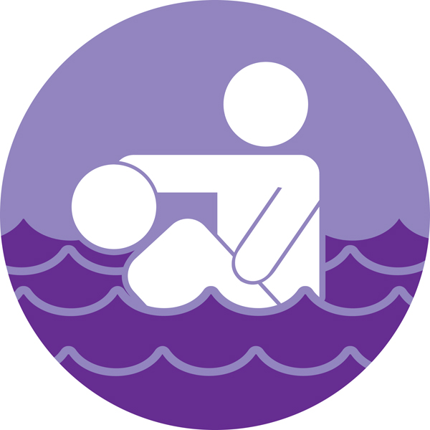
Disciple – Helping people become disciple-makers
Every Christian is called not only to be a disciple (noun) but also to disciple (verb) others. Discipleship, or mentoring, is a life-on-life relationship where a Christian takes responsibility to help a younger believer grow in their faith and spiritual life.

Biblical Basis
- Jesus’ words in Matthew 28:19-20 are a command to His followers to baptize and teach people to obey all of Jesus’ directions.
- The relationship between Paul and Timothy described in Acts, 1 Timothy, and 2 Timothy, is a great example of mentoring.
- The Old Testament has many examples of mentoring relationships including the stories of Moses and Joshua, Elijah and Elisha, and David and his mighty men.
- In 2 Corinthians 3:1-3 Paul explains that the proof of God’s approval on his work was not a letter from men but rather the lives of the Corinthian believers themselves.

Disciple Champion Description
The Disciple Champion will work with the location pastor and leaders to develop, train, encourage, and celebrate mentoring relationships. Responsibilities include:
- Mentor one or more people so that you set a clear example to others.
- Identify potential mentors through input from Pastor, leaders, and Fellowship One.
- Explain the mentoring ministry to leaders and potential mentors. Cast vision through the bulletin, Sunday announcements, baptism testimonies, and in small groups.
- Provide a gathering place on Sundays, such as a Welcome Center, for people who are interested in finding a mentor. Provide First Steps books.
- Train people 2-3 times a year. The appendix in the Purple “Disciple” First Steps book should be a major piece of the training. First training should happen before Easter.
- Assign new disciples to mentors. Keep a list of potential mentors and disciples and try to pair them up. Other ministry leaders may help in this area.
- Track those who are mentoring. Make and update a list of all mentoring relationships.
- Replace mentors who do not keep up with the disciple assigned to them.
- Communicate with your pastor and leaders regularly about the mentoring ministry.
- Honor those who are in mentoring relationships. Award mentors and disciples when they finish each book. Provide purple Disciple t-shirts for mentors.

Goal is to have 10% of Sunday attendance actively mentoring someone through the First Steps books (1:10 attenders).

Key Dates
All Church Baptisms – March 1, June 7, August 2, November 1

Resources
Disciple First Steps Book. Purple t-shirts, First Steps Certificates

Goal Sheet Mentors Goal: ________________

Current List | Prayer List

